**Baher Moursy**

**900131407**

**Java Game Report**

I decided that my game would be 32 pixels based tile game and the theme would be Pokémon. I created a hero and a small “Pikachu” that keeps following him everywhere. The item to be loaded would be a Pokémon ball and I choose that the button “L” would be the loading button and that the button “U” would be the unloading button. The player has to take the ball from its position and take it to the target position to open the door so he can pass and win. I understood from the assignment document that we are supposed to collect coins by stand second on them and to win I have to load and unload for five times, so I assumed that there are five balls, and that every one second a ball will be loaded, and accordingly if the player unloads on the specific target he will have to wait for 5 seconds to unload all the balls to win. I assumed that if he unloaded all the balls a door will open and by passing it the player will win.

The player has 3 lives and if the 3 lives were lost, he loses the game. I created that each level has one more enemy than the one before.

**My test cases (Screenshots are attached below):**

- I tried to pass over any of the houses or trees that are representing the blocks that the player can’t pass through, and the result was that player couldn’t pass through it.

- I walked through an enemy and my lives were decreased by one, and if I reached zero I lose.

- I tried loading the ball for second that are less than 5 and the ball wasn’t completely loaded and accordingly it stayed it’s initial position, and it didn’t disappear from the screen unless I completed the total 5 seconds while standing on it.

- I tried to unload the ball anywhere and I failed, because there is a specific position for the ball to be dropped at; I also had to stay for 5 seconds to unload and so the door to winning would open.

- I tried the menu for the easy, medium, and hard choices and they correctly generated the number of enemies based on the difficulty.

- I tried the starting menu where start game sent me to the difficulty menu and exit game closed the game correctly.

**\* This square on the game indicates the target where the ball should be placed Macintosh HD:Users:bahermursi:NetBeansProjects:Applets:terminate.gif**

**Screenshots of the Game:**

**Main Menu**

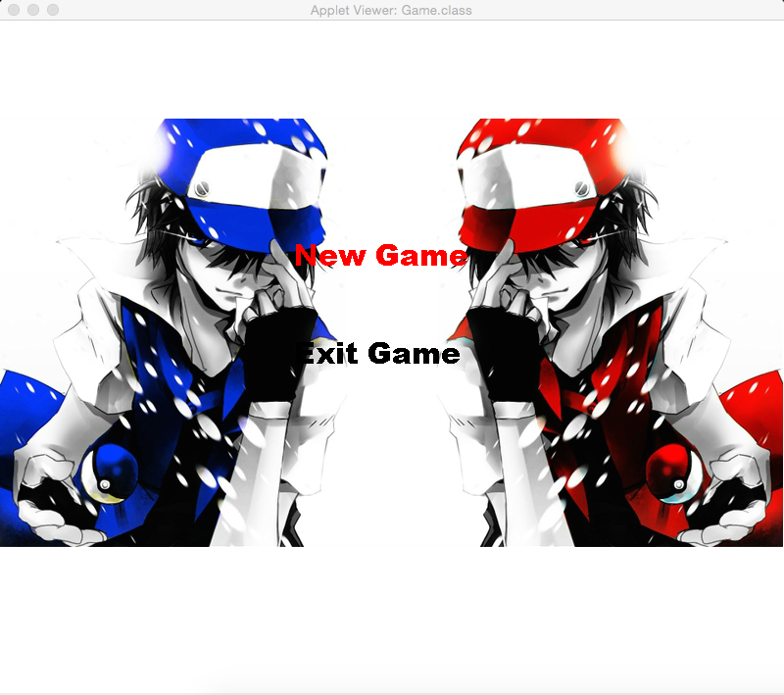

**Difficulty Menu**

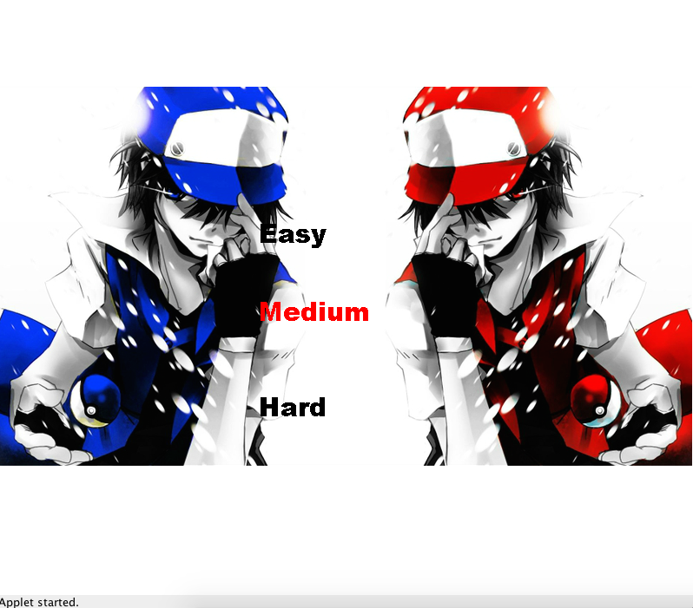

**Level Easy**

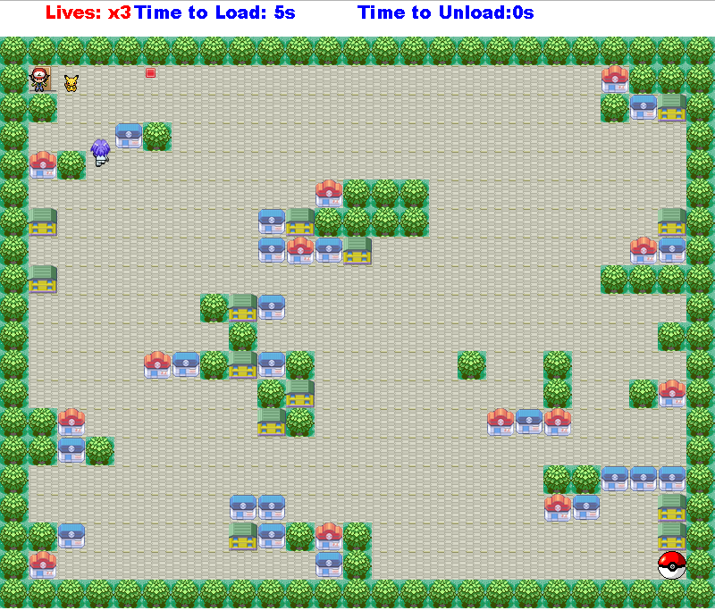

**Level Medium**

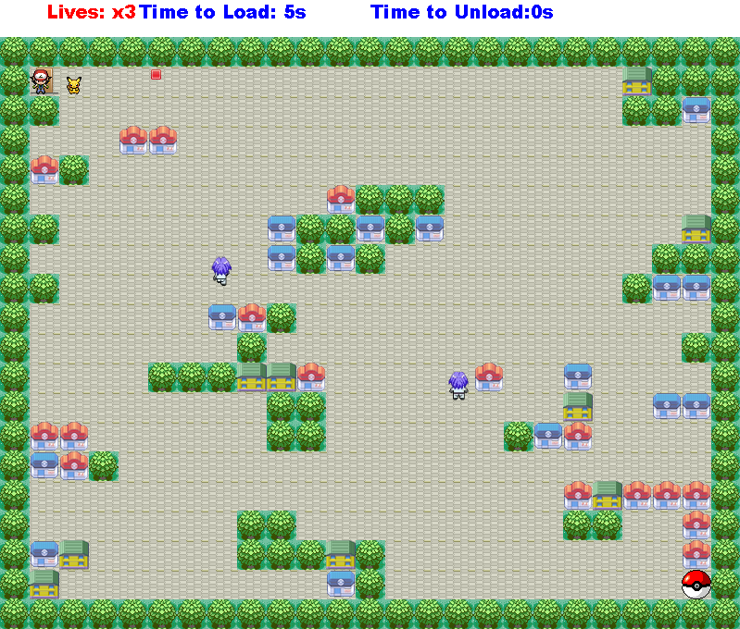

**Level Hard**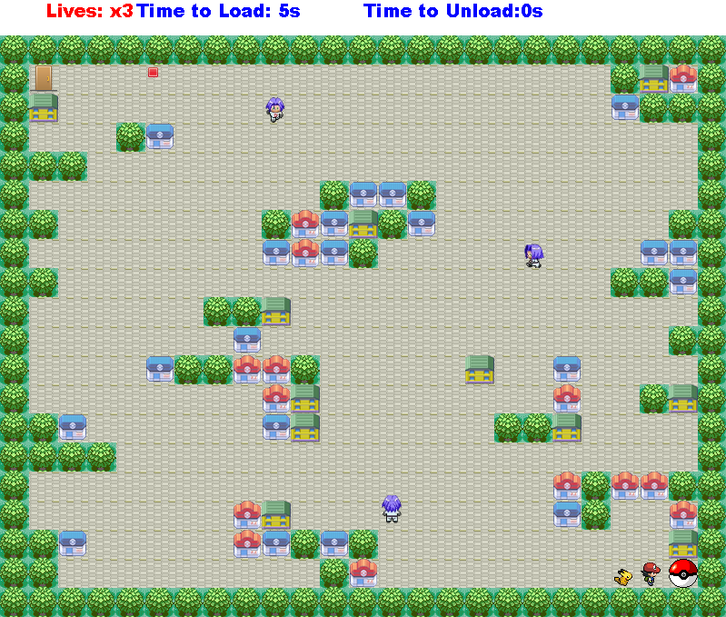

**After loading the ball**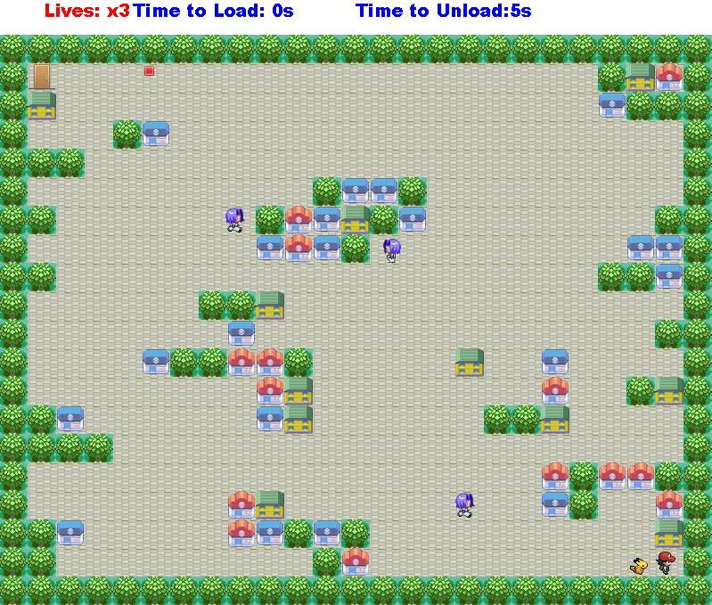

**After unloading the ball**

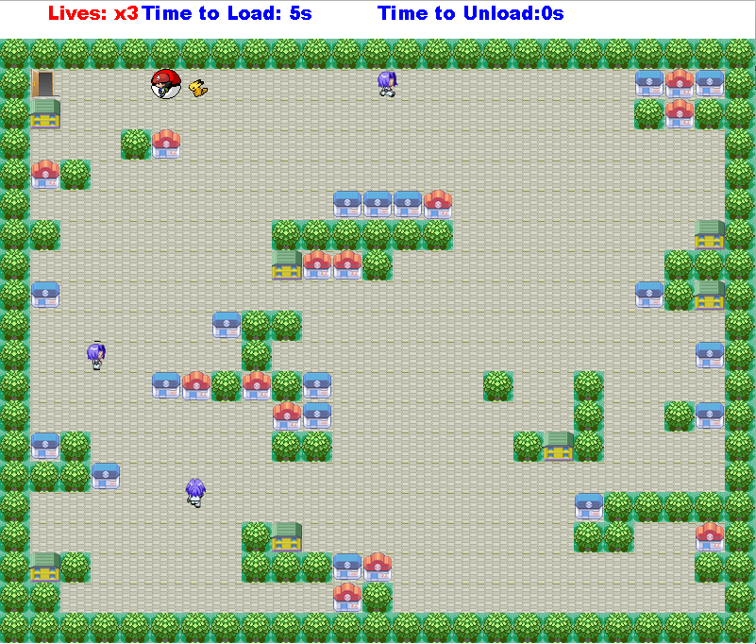

**Lives after walking through an enemy**

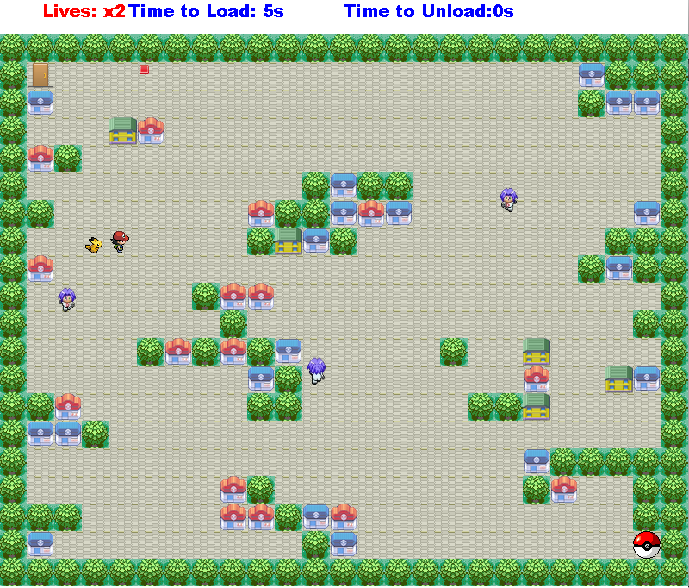

**Winning Window**

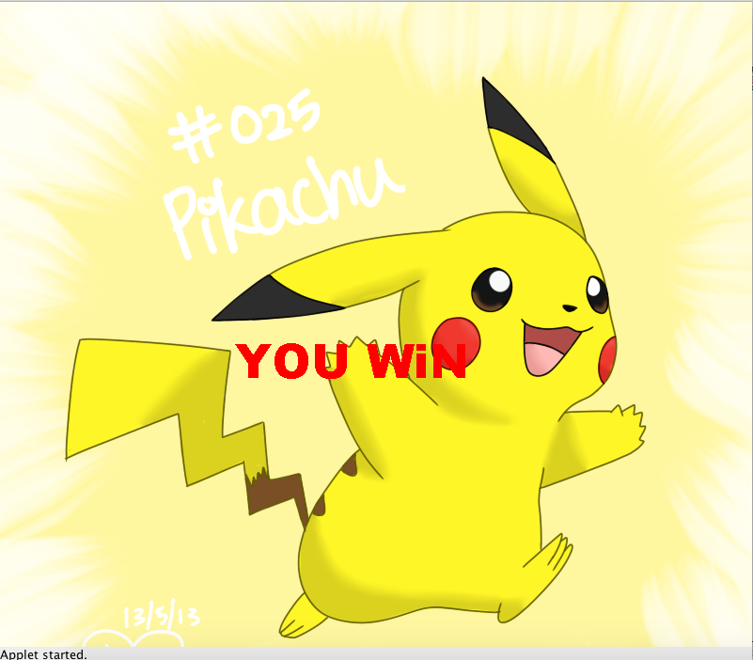

**Losing Window**